Understanding on Android boot sequence:

* The bootloader is in charge of loading the system kernel into the RAM memory and launching it, to continue the boot sequence.
* The most popular bootloader software for Android devices is U-Boot, the Universal Bootloader. U-boot’s main task is to read the kernel image from the boot partition, load it into the RAM memory, and run it. From this moment on, the kernel is in charge of finishing the boot sequence.
* After the bootloader loads the kernel, the kernel’s first task is to initialize the hardware. With all the necessary hardware properly set up, the kernel mounts the ramdisk from boot.img and launches init.
* In a standard Android system, the ramdisk, contained in the boot.img, provides the init script and all the scripts necessary for the boot.
* The Android init process consists of two main files:

init.rc

init.hardware-name.rc

* The init.rc file is the first initialization script of the system. It takes care of initializing those aspects that are common to all Android systems. The second file is very hardware specific. As hardware-name is a placeholder for the reference of a particular hardware where the boot sequence is happening.

eg: init.qcom.rc

* Next, Zygote forks a new ART/Dalvik VM instance and starts the **System Server**.

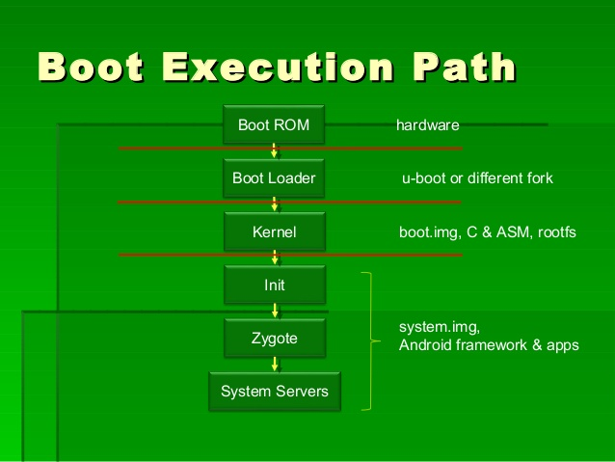

Work done for B2G Nexus-6L source code W.R.T. Android-L :

* Did compare for hardware/libhardware/modules/gralloc,hwcomposer for B2G_Nexus and Android_L and found no changes.

Intention was to create patch file for that if changes found.

* Found out  APIs for

B2G/hardware/qcom/display/msm8084/libcopybit, libhwcomposer, libgralloc and prepared Excel sheets for that.

I referred all header files to capture these APIs and followed .cpp files for their implementation.

These APIs are for display implementation and this activity will help during B2G HAL integration for LS5030 device.

* Also finding out common APIs between B2G/hardware/libhardware/modules/gralloc,hwcomposer and B2G/gecko/widget/gonk/libdisplay,hwchal and found no common APIs for that.

Work Done for B2G Nexus to build for LS5030 code :

* Started building and fixing build errors of B2G Nexus-6L for LS5030.

For that below steps followed for to proceed further :

1. Placed modified  Android.mk, device.mk, msm8909.mk, BoardConfig.mk and AndroidBoard.mk in B2G/device/qcom/msm8909 folder.
2. Placed the zImage-dtb file in msm8909-kernel folder in B2G/device/qcom/msm8909 folder.
3. Extracted sepolicy.zip and placed all files in B2G/device/qcom/msm8909/ folder.
4. Then updated Makefile has been placed in B2G/gaia folder to resolve the dependency errors.

* Analyzing logcat log and kernel log for rebooting issue.

Came to know zygote has been invoked in logcat log.

Then init.rc and init.qcom.rc are also invoked in kernel log.